**E-Fixed Deposits**

**PROJECT ABSTRACT REQUIREMENTS**

**E-Fixed Deposits**

Course-end Project 2

Description

**A global bank to introduce a few feature: *E-Fixed Deposit***

**Current State**

**Overview and Summary**

One of the leading banks across the globe, is ABC Bank. It has a presence in 56 countries in the world.

ABC Bank currently has a manual option to create fixed deposits. The bank users go to the nearest ABC Bank branch and create a fixed deposit. ABC Bank has a future vision of being a 100% online bank and wants to do away with all its manual banking processes. They have identified the need to create e-fixed deposits.

ABC Bank currently wants to introduce this to their existing bank users with a future plan of introducing this feature to non-ABC Bank users.

Advantages of opening an FD online

* **Easy and less time-consuming**: An online FD can eliminate the process of visiting the bank physically and makes the process of creating an FD an extremely easy and hassle-free process.
* **Easy payment:**Paying for the FD is extremely easy and can be done directly through net banking that makes the process of payment very convenient. All that is required is to transfer the money from the savings account to the respective FD account.
* **Easy renewal and closure:** Once an FD account is opened online, it is possible to renew and close the deposit online instantly. Therefore, it eliminates the need of going to the bank for any of these purposes.

ABC Bank invited Business Analysts trained at Simplilearn to capture the requirements to create this feature on their existing web portal.

**Future State**

**ABC Bank has given them the following requirements:**

1. The bank users can create a fixed deposit using their existing online banking account or through their existing mobile banking account.
2. Checklist or requirements for opening ABC Bank FD online are:

* A savings account with ABC Bank
* An online banking account
* A mobile banking account

1. User should be shown various FD rates as mentioned below:

|  |  |  |
| --- | --- | --- |
| Period | Rates for amounts <1.5 Million USD | Rates for amounts >=1.5 Million to < 4 Million USD |
|  | User Rates | Senior Citizen Rates | User Rates | Senior Citizen Rates |
| 7 - 14 days | 3.00% | 3.50% | 3.50% | 4.00% |
| 15 - 45 days | 3.50% | 4.00% | 4.00% | 4.50% |
| 46 – 90 days | 4.00% | 4.50% | 4.50% | 5.00% |
| 91 days – 6 months | 4.50% | 5.00% | 5.00% | 5.50% |
| 6 months 1 day to 1 year | 5.00% | 5.50% | 5.60% | 6.10% |
| 1 year 1 day – 2 years | 5.60% | 6.10% | 5.75% | 6.25% |
| 2 years 1 day – 3 years | 5.75% | 6.25% | 5.50% | 6.10% |
| 3 years 1 day – 5 years | 5.75% | 6.25% | 5.50% | 6.00% |
| 5 years 1 day – 10 years | 5.75% | 6.25% | 5.50% | 6.00% |

The rate applicable to all the Senior Citizens who are 60 years of age and above will be 0.50% above the applicable rate.

1. There should be a fixed deposit calculator. The user will enter his/her age and the amount he/she wants to create an FD for. The FD calculator will display the maturity amount.
2. In cases where a user has multiple bank accounts, he/she should be able to select which account to debit for the FD
3. Users should be able to select one of the two maturity instructions.

* Renew FD for same tenor
* Credit maturity amount to my savings or current account.

1. There should be an option to create Joint FDs. In this case the name of the other customer along with his/her SSN details should be taken.
2. Users should have an option to enter a *nominee*. In case of a nominee, the age should be asked. If the nominee is a minor, then guardian details need to be taken.
3. Once the FD is created. The user should be emailed a PDF copy of the FD.
4. The PDF copy of the FD generated should be reflected in the online banking account and mobile banking account as well.
5. The bank wants to generate certain reports:

* Total value of FDs for users with tenor of less than 6 months.
* Total value of FDs for senior citizens with tenor of less than 6 months.
* Total value of FDs for users with tenor of between 6 months 1 day and 1 year.
* Total value of FDs for senior citizens with tenor of between 6 months 1 day and 1 year.
* Number of FDs that are more than 1.5 Million USD for normal users.
* Number of FDs that are more than 1.5 Million USD for senior citizen users.

**WEEK 1 and WEEK 2**

**Project Task on Business Analysis**

Q1) Identifying Stakeholders – Create a list of stakeholders (as taught in Business Analysis Planning and Monitoring Knowledge Area)

Ans) The list of the stakeholders of ABC Bank are as follows:

1. **ABC Bank Employees:** are those who are working in ABC Bank and has presence in 56 countries in the world
2. **ABC Customers:** are the bank users which go to the nearest bank branch for creation of fixed deposit
3. **ABC Bank Management:**  are the decision makers of the ABC Bank who has a future vision of 100% online bank and is planning to bring online FD in ABC Bank

Q2) Create As-Is and Future Process map (using flowcharts). You can use any of the popular tools in the market like Microsoft Visio, Lucid Chart, Creately, Pidoco, or Balsamiq

Ans) The flowchart of the existing ABC Bank is as follows:

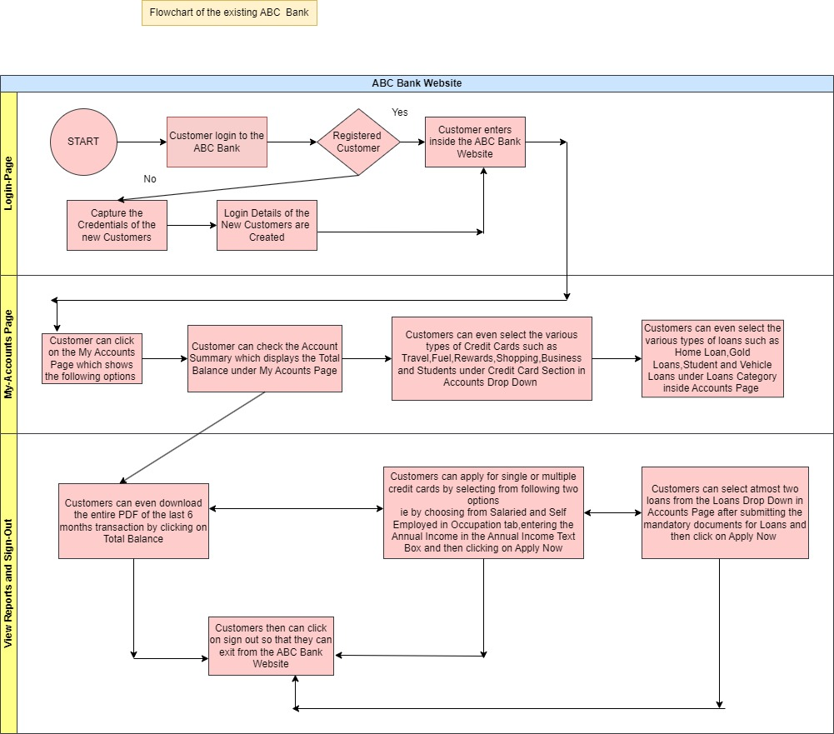

The above mentioned is the as-is Process Map of ABC Bank

The flowchart of new ABC Bank with E-Fixed Deposit is as follows:

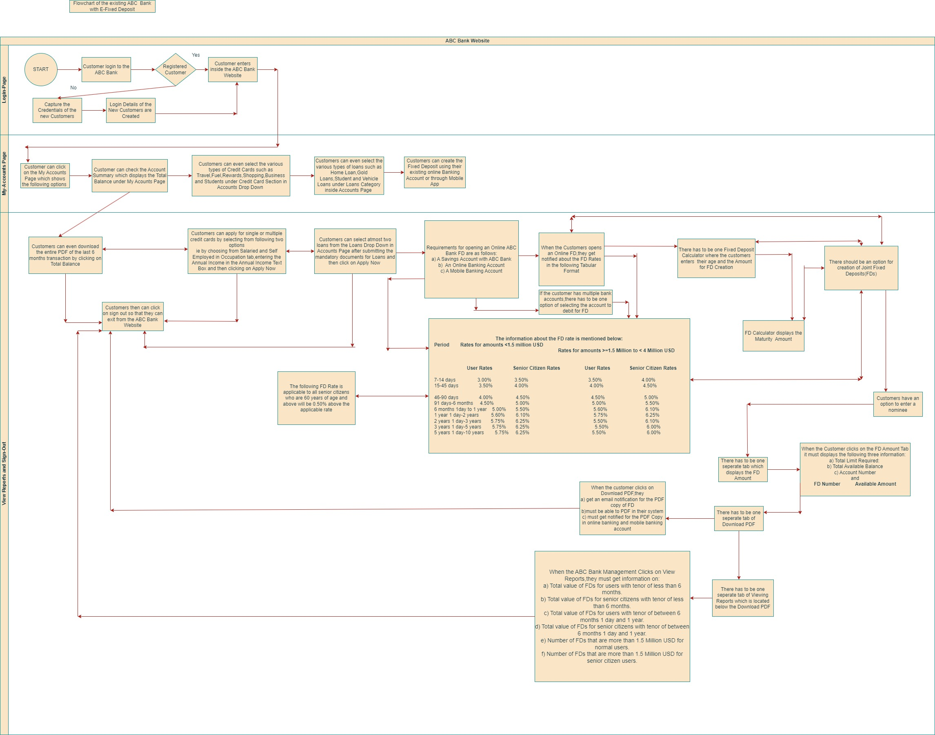

The above mentioned is the future process Map of ABC Bank with E-Fixed Deposit(Use Read Mode for Viewing the diagram)

Q3) As a Business Analyst working on this project, find out the scope of online FD creation. Write down the main features that need to be developed.

Ans) **Scope of the Online FD(Fixed Deposit) Creation**

Scope of the online FD Creation are the boundaries of the online FD.Scope Modelling is one of the acceptance criteria.Scope Modelling can be in-scope or out scope.

Examples of In-Scope of ABC Bank is mentioned below:

1. The ABC Bank has manual option for creation of Fixed Deposit
2. Customers visit the nearest ABC Bank for Fixed Deposit Creation
3. The ABC Bank uses the manual banking process for FD Creation which involves the manual form filling from the Bank Authorities

The main features that need to be developed are as follows:

1. The new ABC Bank with E-Fixed Deposit must have one login page where the credentials of the existing customers are verified along with the registration of new customers
2. The User-Interface of the system must have a window of the username,password and login button
3. Once the customer clicks on the login button,a detailed view of My Accounts tab must be visible
4. When the customer clicks on My Accounts,a detailed view of Account Summary,types of credit cards,types of loans and E-Fixed Deposit has to be visible
5. Once the customer clicks on E-Fixed Deposit,a detailed checklist or requirements for opening ABC Bank online FD must be visible which includes the saving account with ABC Bank,An online banking account and the mobile Banking Account
6. The information about the FD rate must be presented to the customer in the below mentioned tabular format:

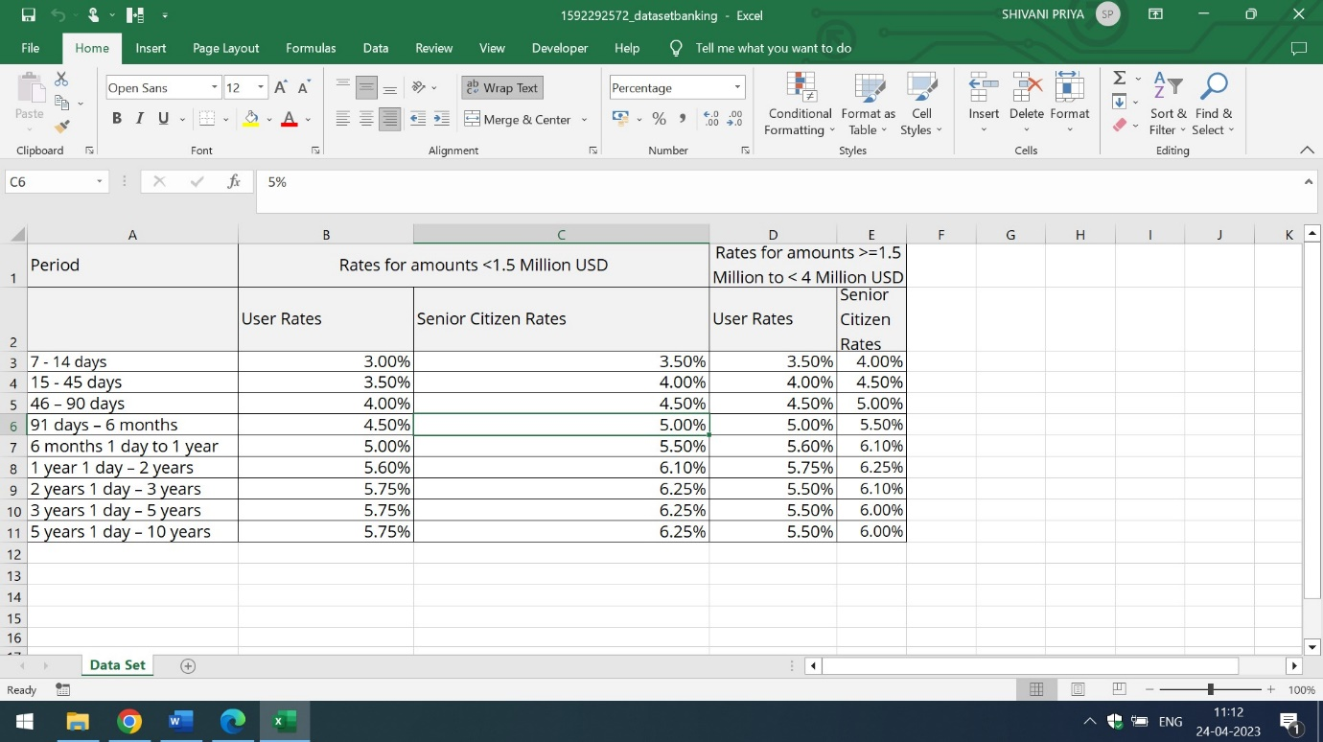

The rate applicable to all the Senior Citizens who are 60 years of age and above will be 0.50% above the applicable rate.

1. There should be one Fixed Deposit Calculator tab which must be present inside the View Reports and Sign Out page where the customer enters the age and the amount of FD Creation. The FD calculator displays the maturity amount
2. If the customer has multiple bank account options,there has to be an option of selecting the account to debit for FD and it must be linked with the online Bank FD creation page and the rates of the FD page
3. There must be a separate column of Joint Fixed Deposit where the customers have an option to enter a nominee
4. When the customer clicks on the Joint FD,a detailed information of Total Limit Required,Total Available Balance,Account Number and FD Number and Available Amount has to be visible
5. There has to be a separate tab of Download PDF which must be present inside the FD Amount Tab
6. When the customer clicks on Download PDF, they get an email notification for the PDF copy of FD,must be able to download the PDF in their system and gets the notification of the PDF copy in online banking and in mobile banking account
7. There has to be separate column of the view reports which is visible to ABC Bank Management only
8. When the ABC Bank Management clicks on view reports,they must get notified through reports of

-Total value of FDs for users with tenor of less than 6 months.

-Total value of FDs for senior citizens with tenor of less than 6 months.

- Total value of FDs for users with tenor of between 6 months 1 day and 1 year.

- Total value of FDs for senior citizens with tenor of between 6 months 1 day and 1 year.

- Number of FDs that are more than 1.5 Million USD for normal users.

- Number of FDs that are more than 1.5 Million USD for senior citizen users.

Q4) Write the in-scope and out-of-scope items for this software.

Ans) In-Scope requirements of the software are the requirements which lie inside the boundary While out-scope requirements of the software are the requirements which lie outside the boundary Some of the In-Scope and Out-Scope requirements are listed below:

**In-Scope Requirements:**

1. Only the customers of the ABC Bank Branches which has presence in 56 countries can use the online ABC Banking Website with E-Fixed Deposit
2. The web page of the ABC Bank Website must contains the three pages ie Login Page,My Accounts Page and View Reports page
3. The login page has the User-Interface of accepting the existing and new customers credentials, The My Accounts Page has the My Accounts tab which displays the Total Balance,Credit Card Types,Loan Types and E-Fixed Deposits in Banking Account and Mobile App and The View Reports Page has separate tab and columns of online FD Creation,Joint FD Creation with nominee option , Download PDF Tab which is accessible to all customers of ABC Bank and the last one is View Reports Tab which is visible to only ABC Bank Management
4. The sign out option must be present at the last section of the View Reports tab so that the customers and the ABC Bank Management can sign out successfully

**Out -of -Scope Requirements:**

1. Only the citizens of the 56 Countries where the ABC Bank has their presence and branches can use the automated ABC Banking Website with e-fixed deposit. If any other citizen apart from these 56 Countries are using the ABC Bank Website then it comes under Out-of Scope Requirement
2. If the employees of any alternate bank are using the ABC Bank Website with E-Fixed Deposit,then it also comes under Out-of Scope Requirement. Only the ABC Bank employees have permission to use the ABC Bank Website
3. If any alternate Bank Management are viewing the reports inside the ABC Bank Website with E-Fixed Deposit then it is also a part of Out-of scope requirements. Only the ABC Bank Management have permission to view the reports in View Reports Tab of ABC Bank Website
4. Only the Saving Account with ABC Bank is required for online FD Creation. If Current Accounts,Demat Account are used for opening an online FD then it is categorized under Out-of Scope Requirements
5. If the Fixed Deposit Calculator is asking for Customer’s Address, Customer’s City or Date-of Birth related information then it is also viewed as Out of Scope Requirement of the Software. FD calculator only asks for the customers age and the amount he/she wants to create an FD for. The FD calculator will display the maturity amount.

Q5) Write out the business requirements, both functional and non-functional requirements.

Ans) **Functional Requirements**: are the requirements which must be present in the product. These are the functions which developer must enable to accomplish their tasks Some of the functional requirements of automated Bank Website with e-fixed deposit are listed below:

1. The home page of the automated Bank Website must contains the label of username and password. The textboxes must be assigned to username and password fields and there has to be one submit and reset button for capturing and erasing the user details from the assigned textboxes.When the user clicks on the submit button,the accounts tab must appears on the top of the page in the software
2. When the user clicks on Accounts Tab, a detailed drop down should appear which contains the Account Summary,Credit Cards list,loan types and e fixed deposit options in the drop down view
3. On Clicking the Accounts Summary it must display the Total Balance, there has to be one option of hiding the balance also.When the Customer clicks on Credit Cards the various types of Credit cards such as Travel,Fuel,Rewards,Shopping,Business and Student has to be visible in the options format.
4. On Clicking the Loan type,the various types of loans such as Home,Gold,Student and Vehicle should be visible to the customer
5. The last option is of e-fixed deposit which is present at the last section of the My Accounts Page
6. The last page is of View Reports and Sign Out Page.There has to be a separate column of online FD Creation.When the Customer clicks on the online FD,it must display the two rows in the slide show fashion. The first row displays the requirements for opening an Online ABC Bank FD which includes the information of the saving Account,An Online Banking Account and the mobile Banking Account while the second row gives information about the FD rates in the below mentioned tabular format:



1. View Reports and Sign out page of ABC Bank shall have one separate tab of Fixed Deposit Calculator. When the user clicks on Fixed Deposit Calculator, a detailed drop down must appear in front of user which contains the two labels and two text boxes. The name of first label is to enter the customer age and the second one is amount for FD Creation. The two text boxes must be placed in front of these two labels and has to be white in color. There has to one button which is labelled as FD Calculation. When the customer clicks on FD Calculation, it must display the Maturity amount to the user
2. There has to be a separate column of Joint FDs which is present at the right side of the Fixed Deposit Calculator. When the Customer clicks on the Fixed Deposit Calculator,it must display the name of nominee if the nominee is registered. If the nominee is unregistered, it shall ask for the nominee name
3. There has to be a separate tab of Total FD Amount. When the user clicks on the Total FD Amount,it must display the total limit required,Total Available Balance,Account Number as well as FD Number and Available Amount
4. The Download PDF Tab must be present below the FD Amount Tab. When the customer clicks on the download pdf, they get an email notification for the PDF copy of FD,they must be able to download the PDF in their system and gets the notification of the PDF copy in online banking and in mobile banking account
5. The second last column is of the view reports which is visible to the ABC Management only so that get notified through reports of

-Total value of FDs for users with tenor of less than 6 months.

-Total value of FDs for senior citizens with tenor of less than 6 months.

- Total value of FDs for users with tenor of between 6 months 1 day and 1 year.

- Total value of FDs for senior citizens with tenor of between 6 months 1 day and 1 year.

- Number of FDs that are more than 1.5 Million USD for normal users.

- Number of FDs that are more than 1.5 Million USD for senior citizen users.

q) The last column is of sign-out. When the user clicks on sign-out,they must be able to successfully sign out from the ABC Bank Website

**Non-Functional Requirements:** are the qualities of the system.These are the quality attributes.These are basically the support features. Some of the Non-Functional requirements are:

1. **Availability:** The automated Bank Website along with E-Fixed Deposit is available for ABC Bank Employees and Customers which has presence in 56 countries in the world
2. **Compatibility**: The software must handle the registration of ABC customers of 56 countries
3. **Usability**: The software is easy to use for ABC Bank employees and customers
4. **Security:** The automated Bank Website along with E-Fixed Deposit can handle threats,viruses and malicious attacks
5. **Localization:** The user interface of the software is designed in English language and the rates of the FD are mentioned in USD
6. **Extensibility:** The software can incorporate new features according to Stakeholders requirements
7. **Compliance:** Only the ABC Bank Management,ABC Bank employees and the customers of 56 countries of ABC Bank Branches have access of ABC Bank Website. If any alternate Management of Bank and employee or customers try to login in ABC Website it will show the authentication error and wont accept the credentials
8. **Portability:** The ABC Bank employees of 56 countries can access the automated software on every desks. It must be portable and handy

Q6) Draw wireframes or mock screens for any two of the features. Use the technique prototyping or wireframing that is taught in the training. You can use any of the wireframing tools like Microsoft PowerPoint, Microsoft Word, Balsamiq, Sketch, Adobe XD, Adobe ILLustrator, Figma, UXPin, InVision Studio, Invision Freehand, or Moqups.

Ans) The wireframe of the accounts overview of Automated ABC Bank Website with E-Fixed Deposit is mentioned below:

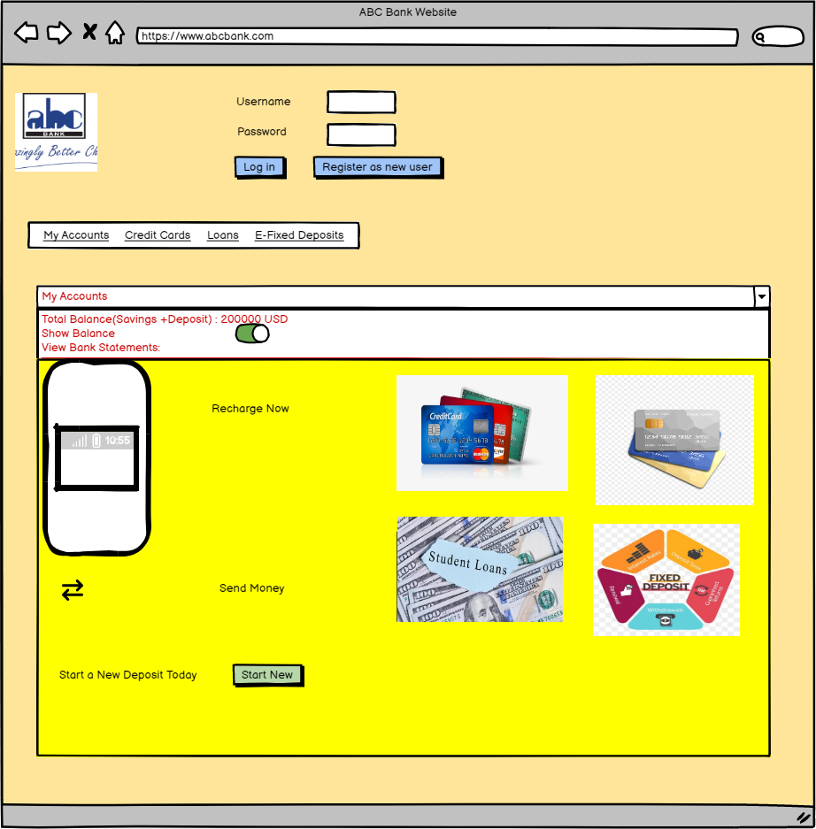

The wireframe of E-Fixed Deposit without Joint FD is mentioned below:

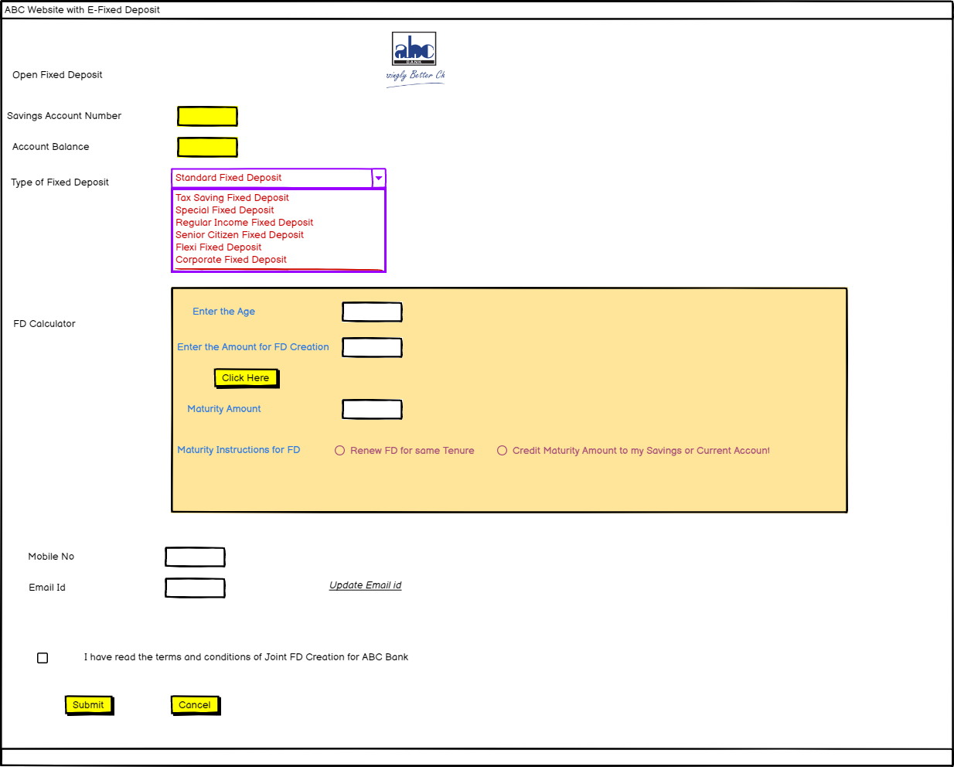

WEEK 3 : AGILE PLANNING AND ANALYSIS

**Project on E-Fixed Deposit of Agile Scrum**

Q1) Make a product backlog of user stories for the given case study. User Stories should be in the format of As a <type of user>, I want <goal> so that <reason>

Ans) The Product backlog of user stories for E-Fixed Deposit are mentioned below:

1. As a user, I want login page of ABC Bank shall have labels of username and password along with two text fields as well as login and Register as new user button so that user can successfully login inside the ABC Bank
2. As a user I want My Accounts label has to be visible on the first page of ABC Bank so that customers can view the Total Balance, Credit Cards,Loan Types and E-Fixed Deposit in drop down
3. As a user,I want My Accounts label has to be red in colour and clickable so that it display the Total Balance, View Bank Statements and new Deposit Creation in a drop Down
4. As a user, I want credit cards label has to be underline and black in colour so that it can show the various credit card types in a drop down
5. As a user, I want Loans Label has to be underline and black in colour so that it will display the various loan types in drop down
6. As a user, I want E-Fixed Deposits has to be clickable and black in colour so that it display the FD Maturity Amount in the drop down

These are some of the epics of the E-Fixed Deposit

1. Login-Page
2. Accounts Page
3. My Accounts Drop Down
4. Credit Cards
5. Loans
6. E-Fixed Deposits

The below mentioned are some of the screenshots of the epics and product backlog user-stories. Please note they are not the complete dump but to demonstrate Jira workflow , I have shown workflow for EPIC 1.

Q2) For each story, write the acceptance criteria

Ans) These are the **acceptance criteria of login-page**

a) User Must be able to click on login and register as new user buttons

b) The colour of login and register as new user button has to be light blue in colour

c) When the user types the password in the password text box, it has to be represented in * format

d) If the username exists previously in the database, then the textbox must display the warning message while typing the username in the username text field

e) The text field of username must display the right symbol in green colour if it accepts the username

f) The text field of password must display the right symbol in green colour if it accepts the password

These are the **acceptance criteria of Accounts Page**

a) The label of My Accounts has to be underline and black in colour

b) When the user clicks on My Accounts, it must display My Accounts,Credit Cards,Loans and E-Fixed Deposit in a scroll bar view

c) All these options present under My Accounts has to be clickable

These are the **acceptance criteria of My Accounts Drop Down**

1. My Accounts label must be red in colour and must be visible inside the combo box
2. When the customer clicks on My Accounts, it should display the Total Balance in USD,Show Balance with an on-off switch and view bank statements
3. There has to be label of Recharge Now which is placed at the right side of phone symbol, send money label with double arrow symbol and start a new deposit label with start new command button in light green colour

These are the **acceptance criteria of Credit Cards Page**

a) The Credit Cards text has to be underline, clickable and black in colour

b) The Credit Cards must include the Travel,Fuel,Shopping,Rewards,Business and Students credit card categories in the drop down

c) User must be able to select at most three credit cards based on their personal and financial information such as name,gender,occupation,mobile no,email,Gross Monthly Income and Mortgage Payment Monthly

These are the acceptance criteria of Loan Page

a)The Loans label must be underline and black in colour

b) When the user clicks on loans, it must display the various loan types such as Home,Gold,Student and Vehicle in loan categories

c) User must be able to select various loan types based on KYC,Monthly Income and Credit Score

These are the **acceptance criteria of E-Fixed Deposit**

a)The E-Fixed Deposit has to be underline and black in colour

b) When the user clicks on the E-Fixed Deposit it must open the browser window with ABC Website with E-Fixed Deposit as header in the browser window

c) There has to be a logo of ABC which must be visible to the user

d) For opening the Fixed Deposit,user must enter the Savings Account Number in the Text Box

e) There has to be a label of Savings Account Number associated with yellow text box, Account Balance associated with yellow text box,Type of Fixed Deposit with Tax Savings,Special Fixed,Regular Income,Senior Citizen,Flexi Fixed and Corporate Fixed in a combo box menu

f) There has to be a label of FD Calculator associated with a text area

g) The text area of FD Calculator shall contains the label of age,amount for FD Creation and Maturity Amount associated with white text boxes

h) There has to be a yellow submit button placed under the amout of FD Creation label

i) User shall be able to select one option from renew fd for same tenure and Credit Maturity Amount to my Savings or Current Account which is attached with Maturity Instructions for FD Label

j) There has to be a label of Mobile Number associated with white text box and email id with white text box outside the text area of FD Calculator

k) There must be a link of Update email id

l) There has to be a checkbox with I have read the terms and conditions of Joint FD creation for ABC Bank Caption

m) There has to be two yellow command buttons with submit and cancel caption

These are the acceptance criteria of E-Fixed Deposit with Joint FD’s

a)When the user clicks on Joint FD’s Tab,it shall ask for the name of the nominee for new users of ABC Bank

b) For existing users of ABC Bank,it must display the name of the nominee

c) There has to be a label of name of the nominee along with white text box

These are the **acceptance criteria of View Reports section:**

a) The View Reports tab has to be underline and black in color

b) When the user clicks on view reports,it must open the PDF files of FD which are easily downloadable in the system

c) There has to be a checkbox with Email Pdf copy of FD caption

d) When the user clicks on the above checkbox, they should be emailed a PDF copy of FD

These are the **acceptance criteria of Certain Reports Tab**

a) Certain reports section has to be visible for ABC Bank Management only. This certain reports section is not visible to any alternate Bank Management and even to ABC Bank Customers and employees

b) When the Management of ABC Bank clicks on Certain reports,it shall generate the following options in a drop down view. The options are listed below

* Total value of FDs for users with tenor of less than 6 months.
* Total value of FDs for senior citizens with tenor of less than 6 months.
* Total value of FDs for users with tenor of between 6 months 1 day and 1 year.
* Total value of FDs for senior citizens with tenor of between 6 months 1 day and 1 year.
* Number of FDs that are more than 1.5 Million USD for normal users.
* Number of FDs that are more than 1.5 Million USD for senior citizen users.

c) All the above-mentioned options has to be clickable and must generate the PDF view in separate browser

WEEK 3 : AGILE PLANNING

Screenshots EPIC 1 :

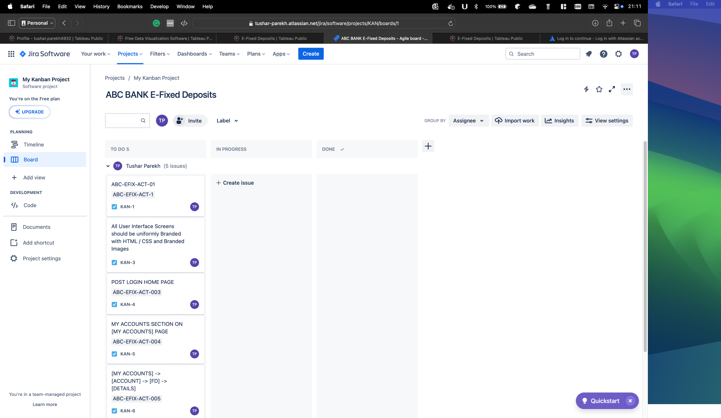

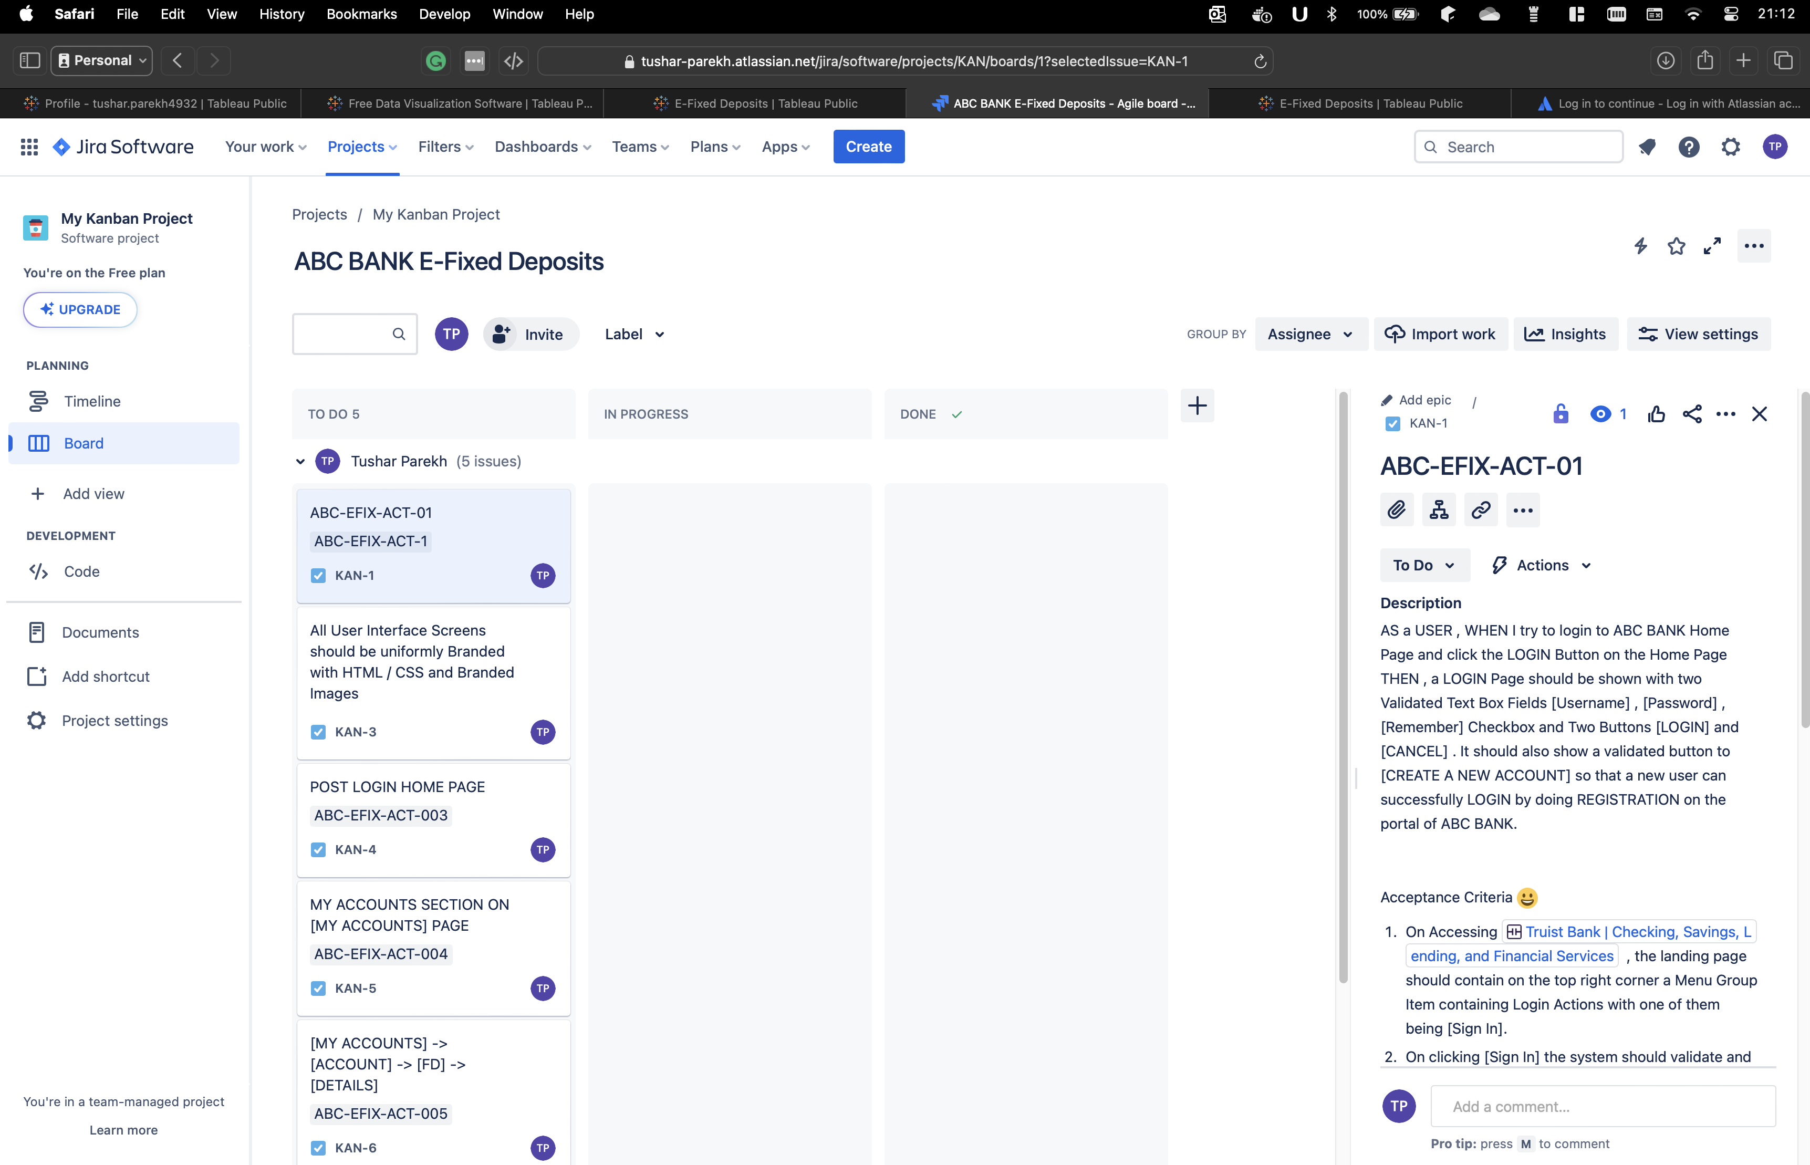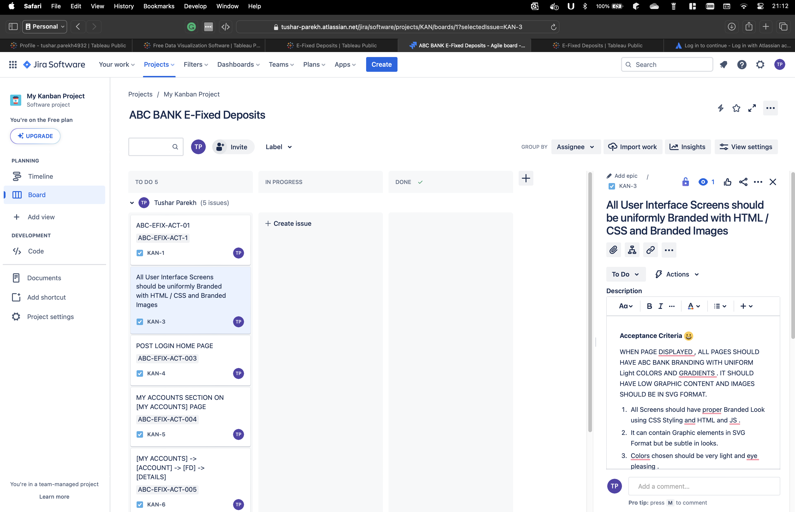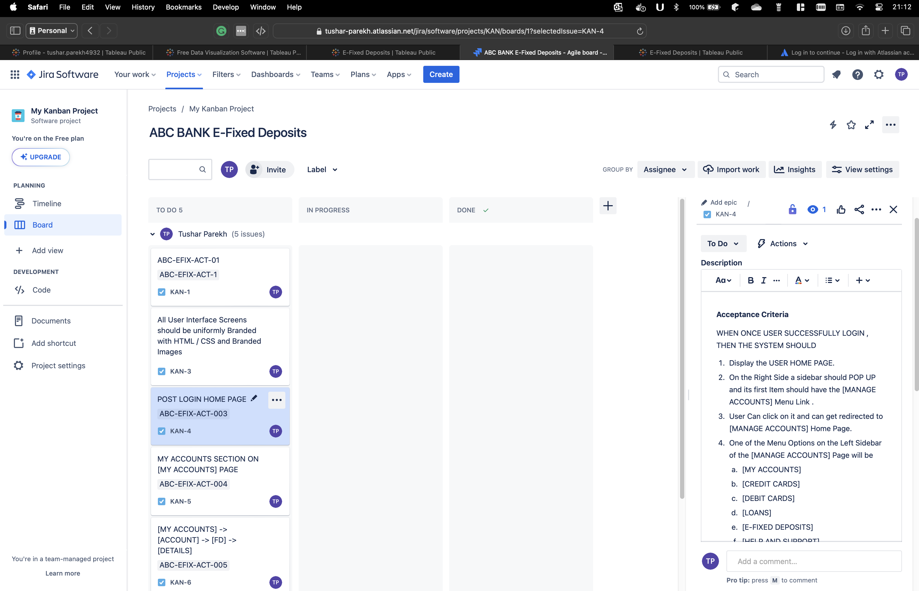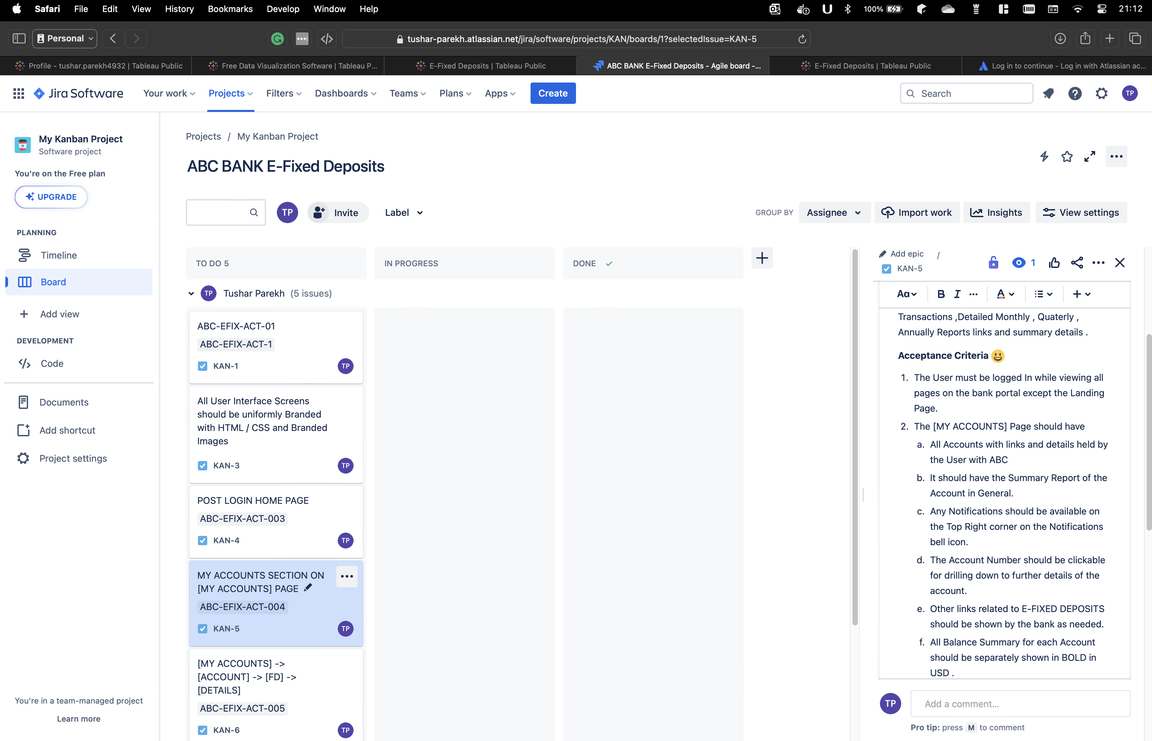

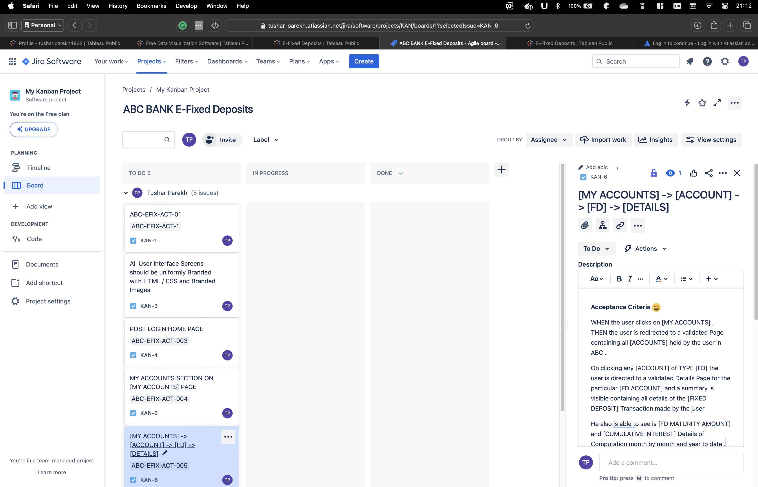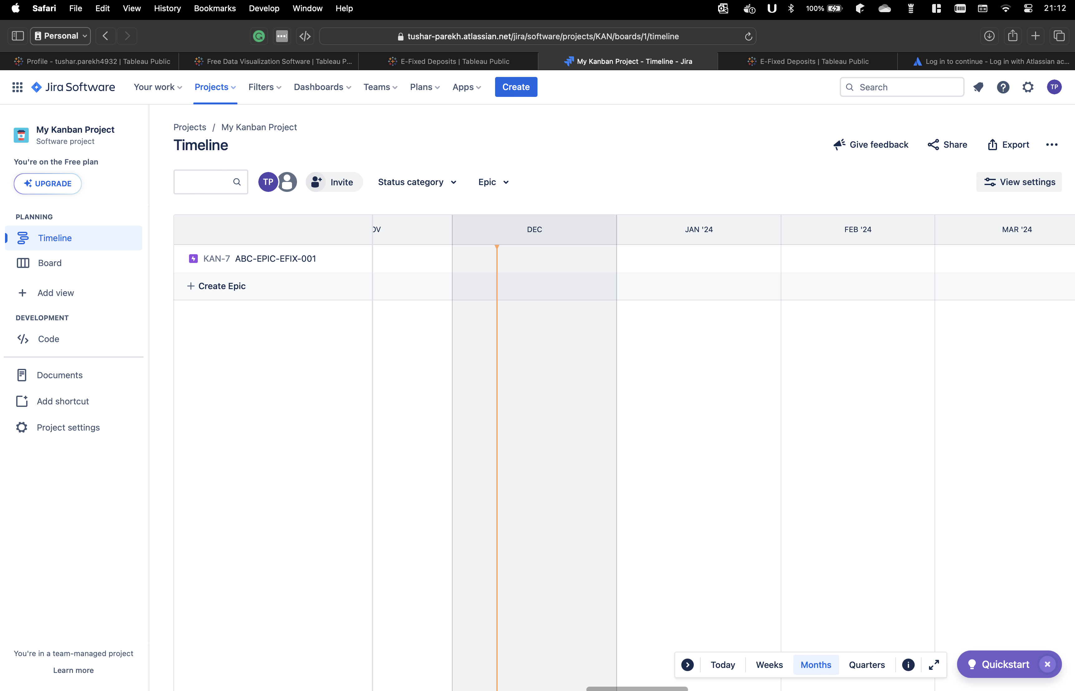

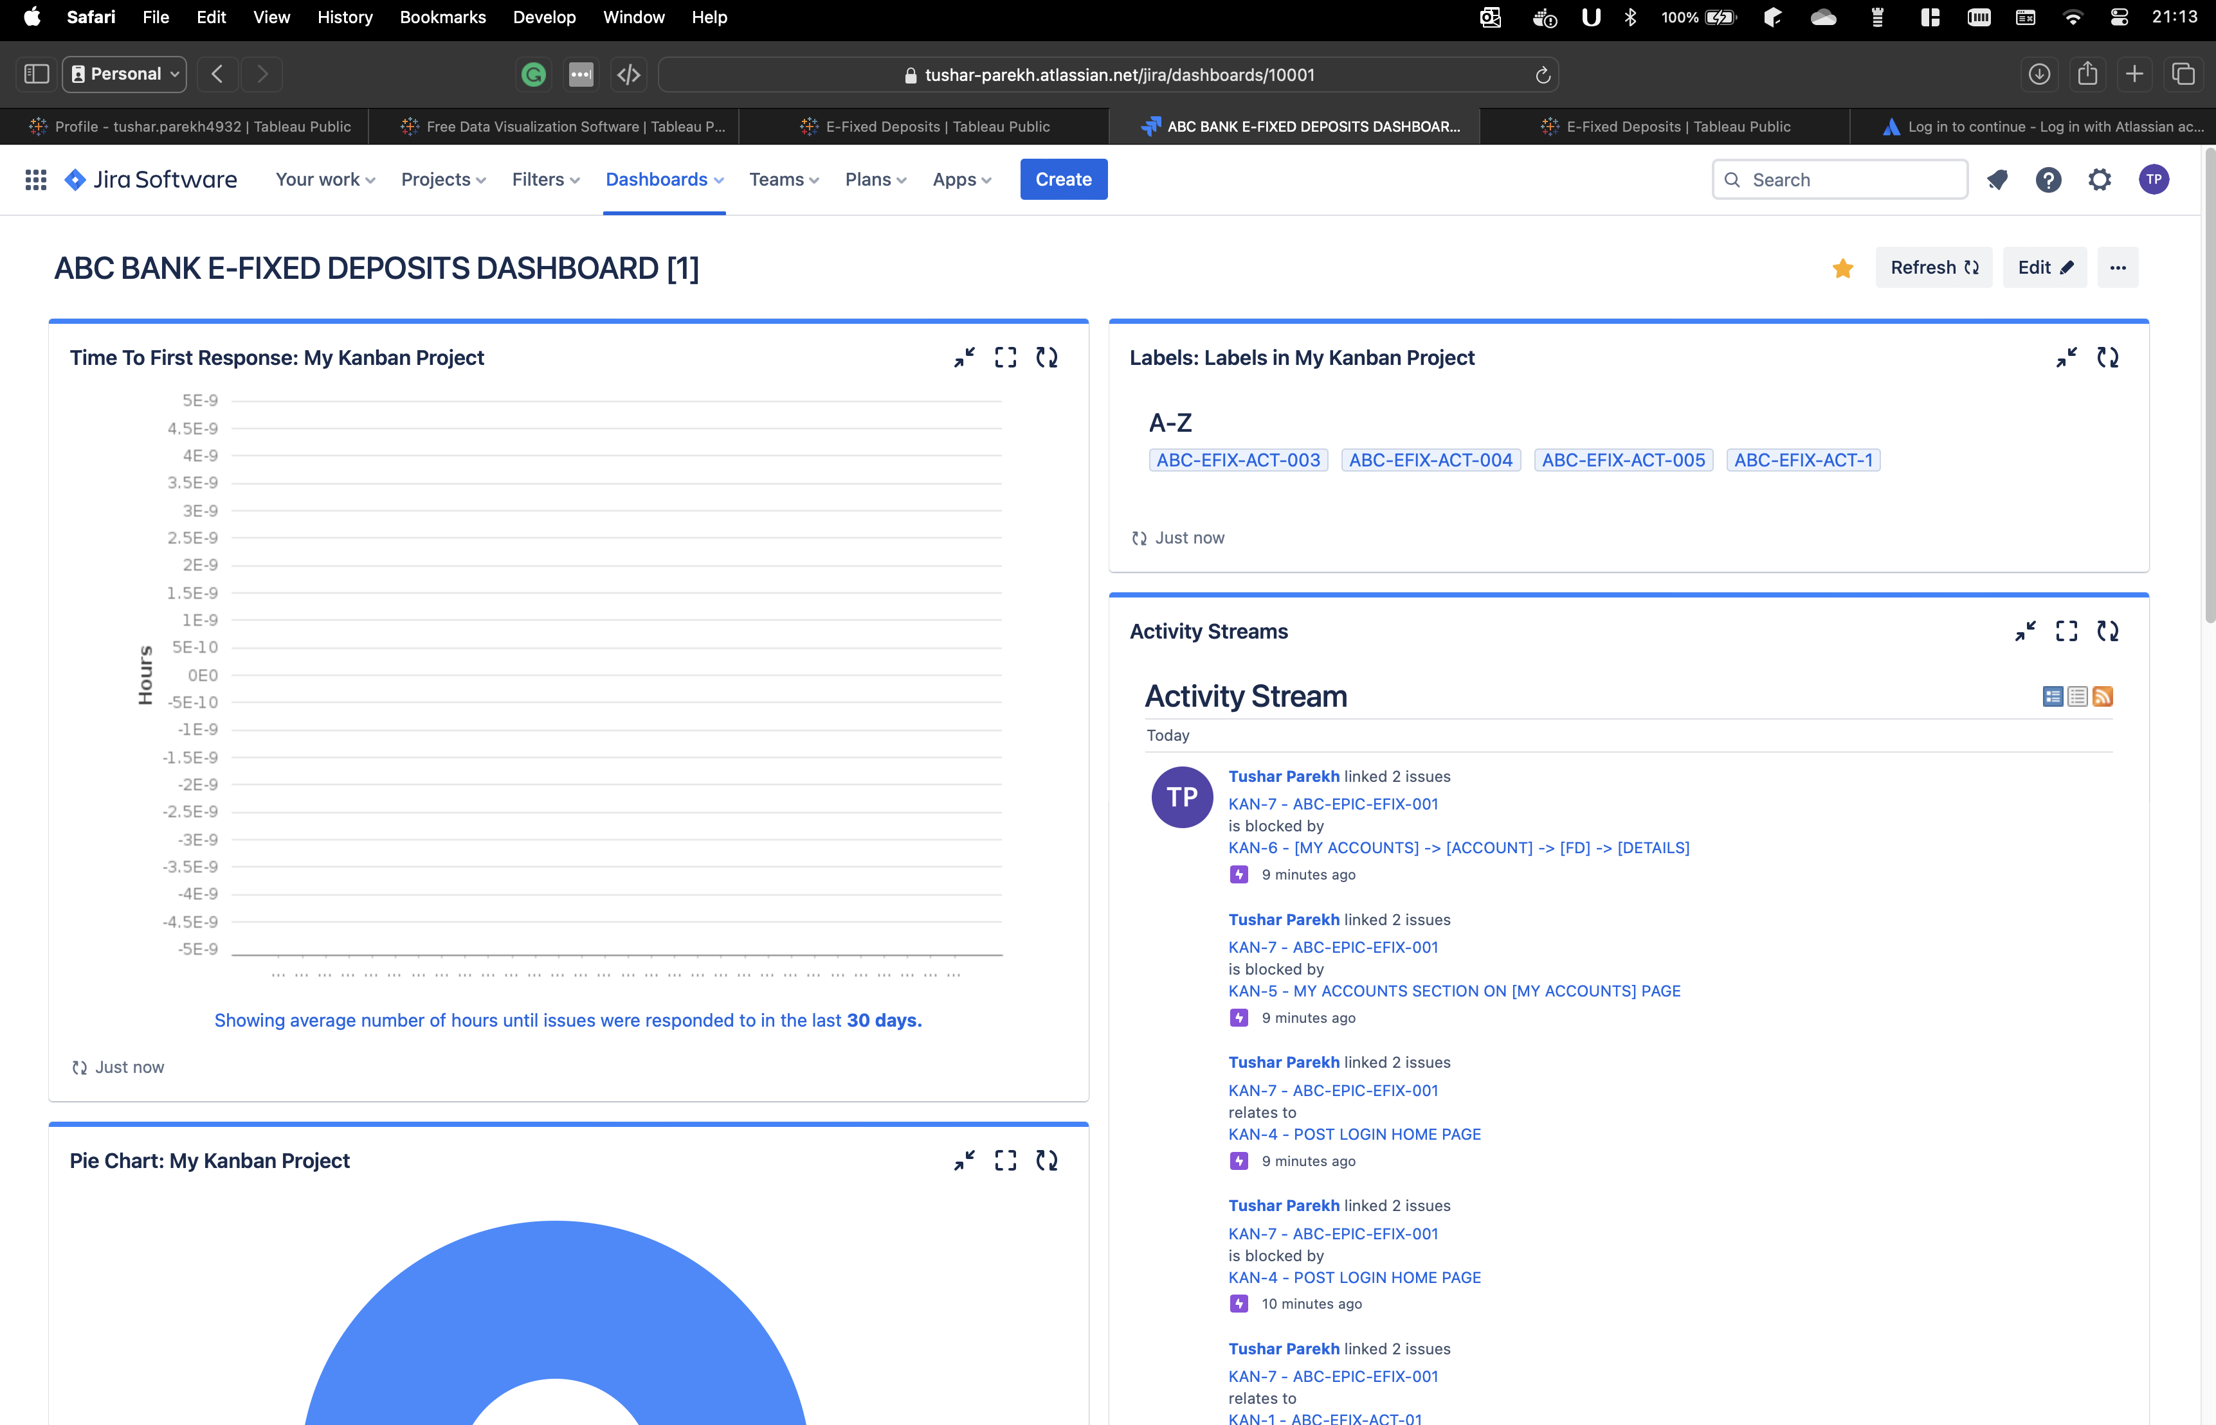

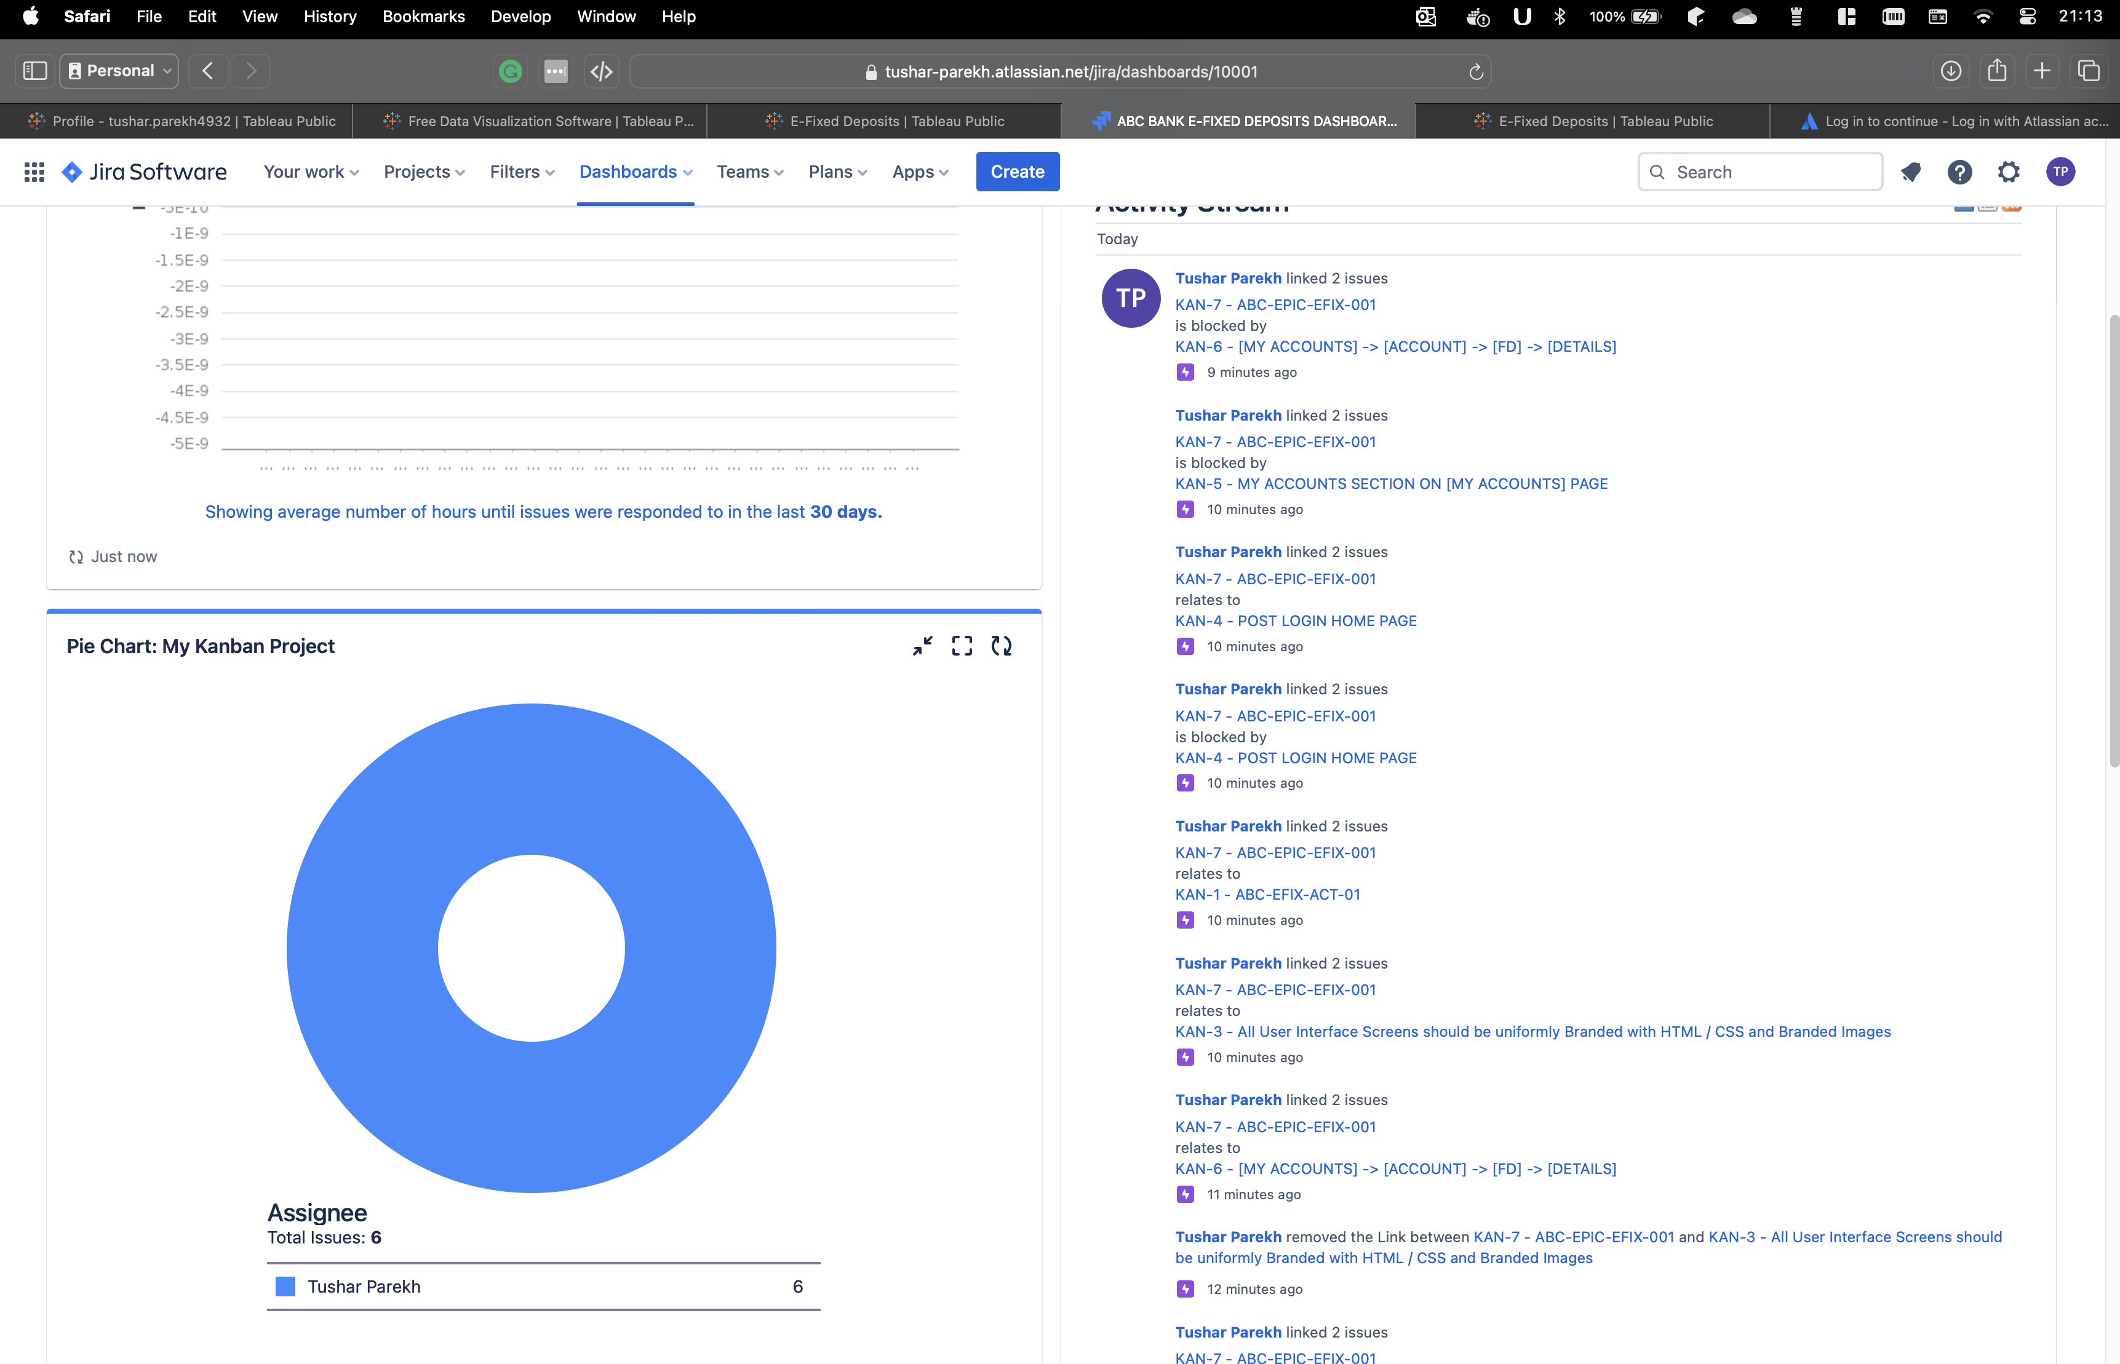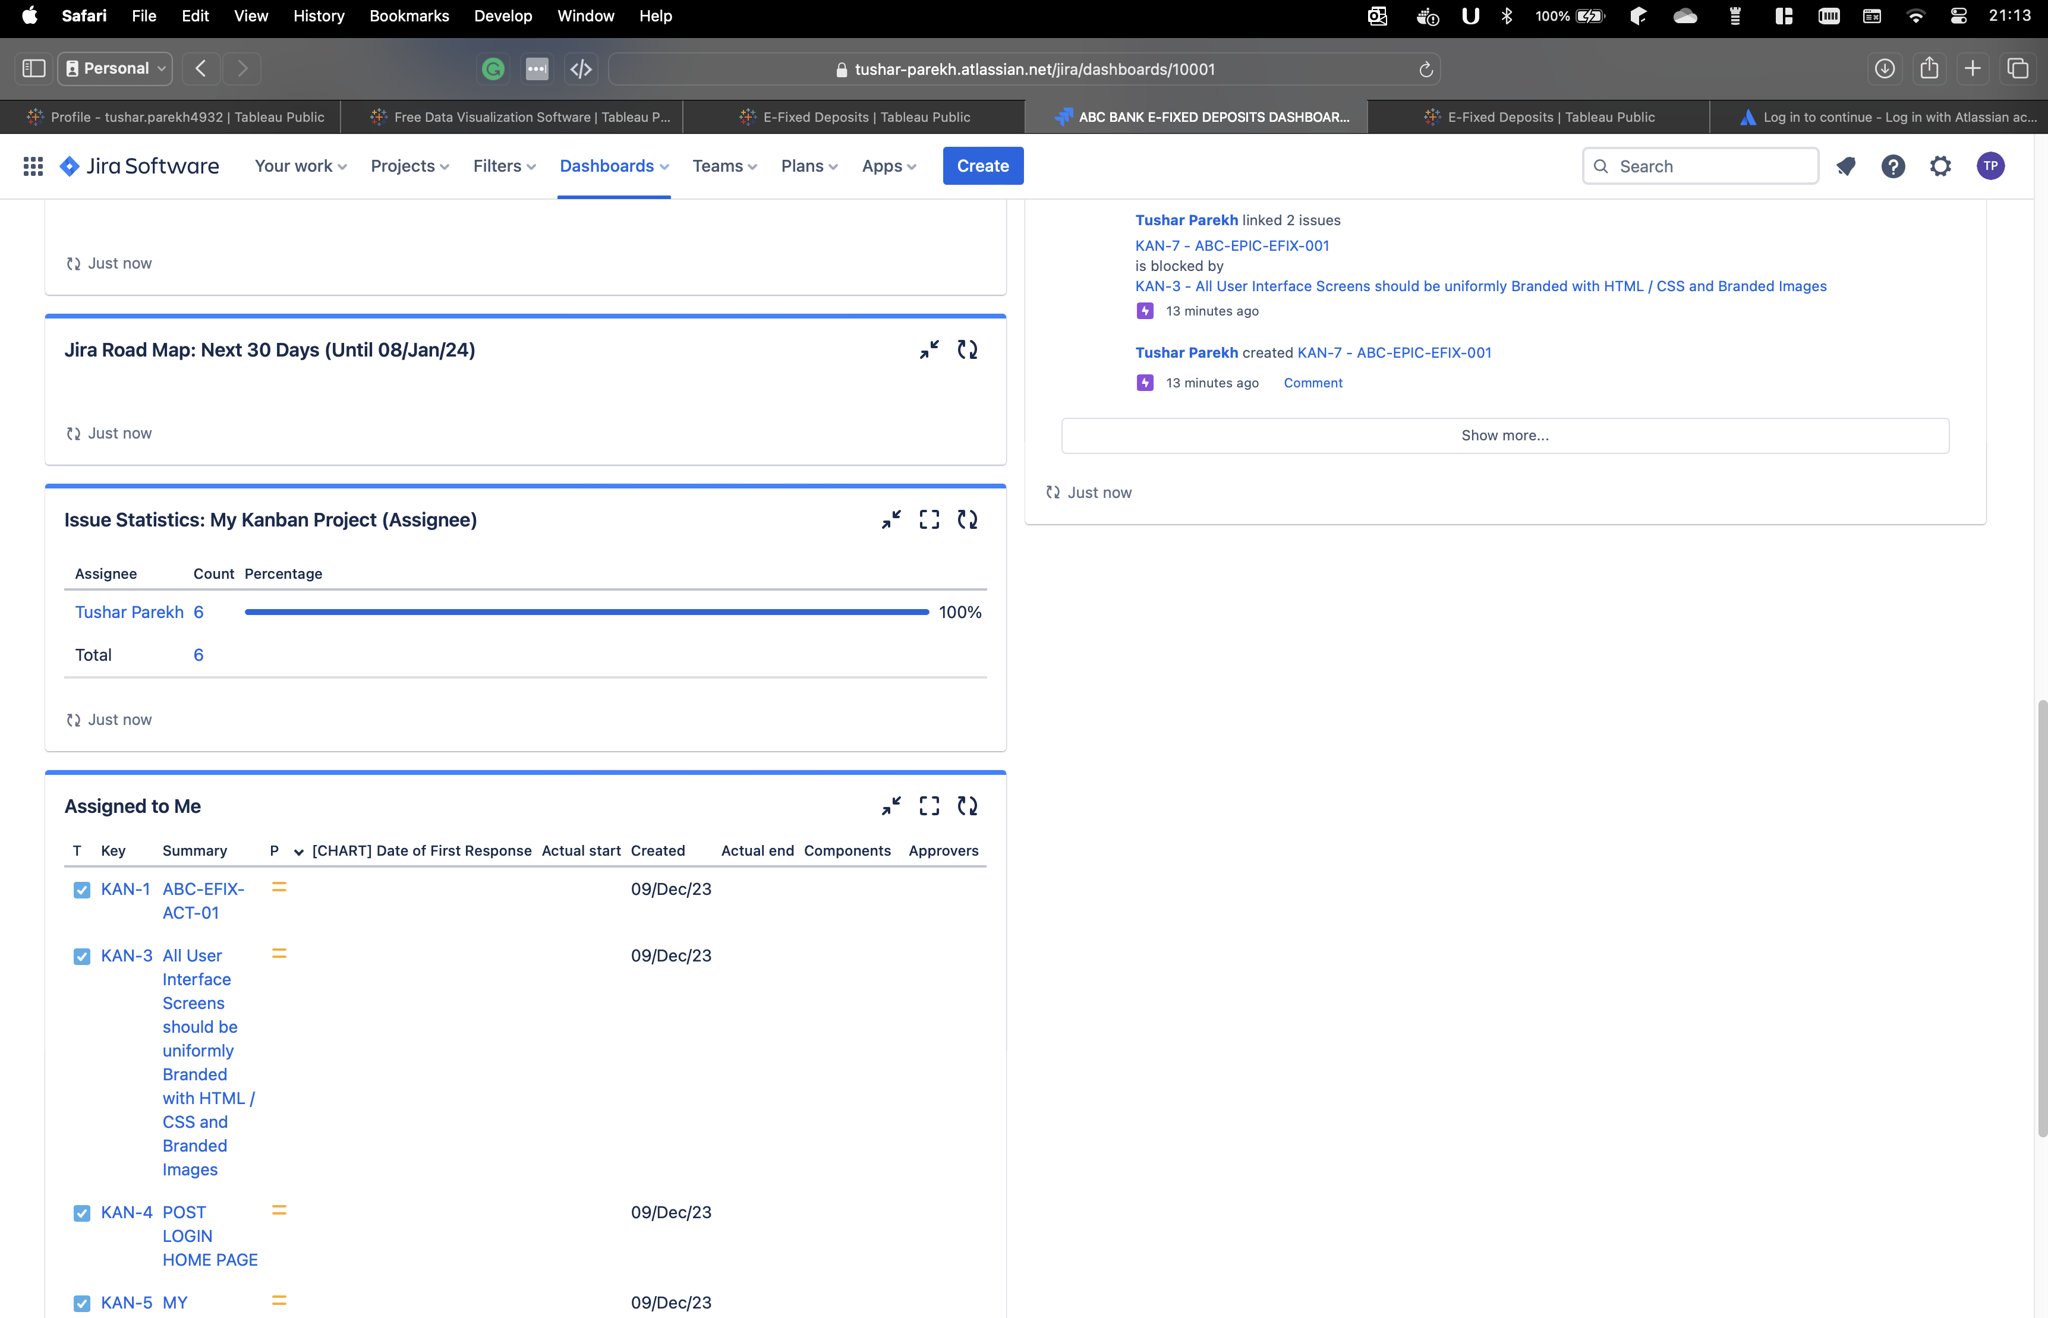

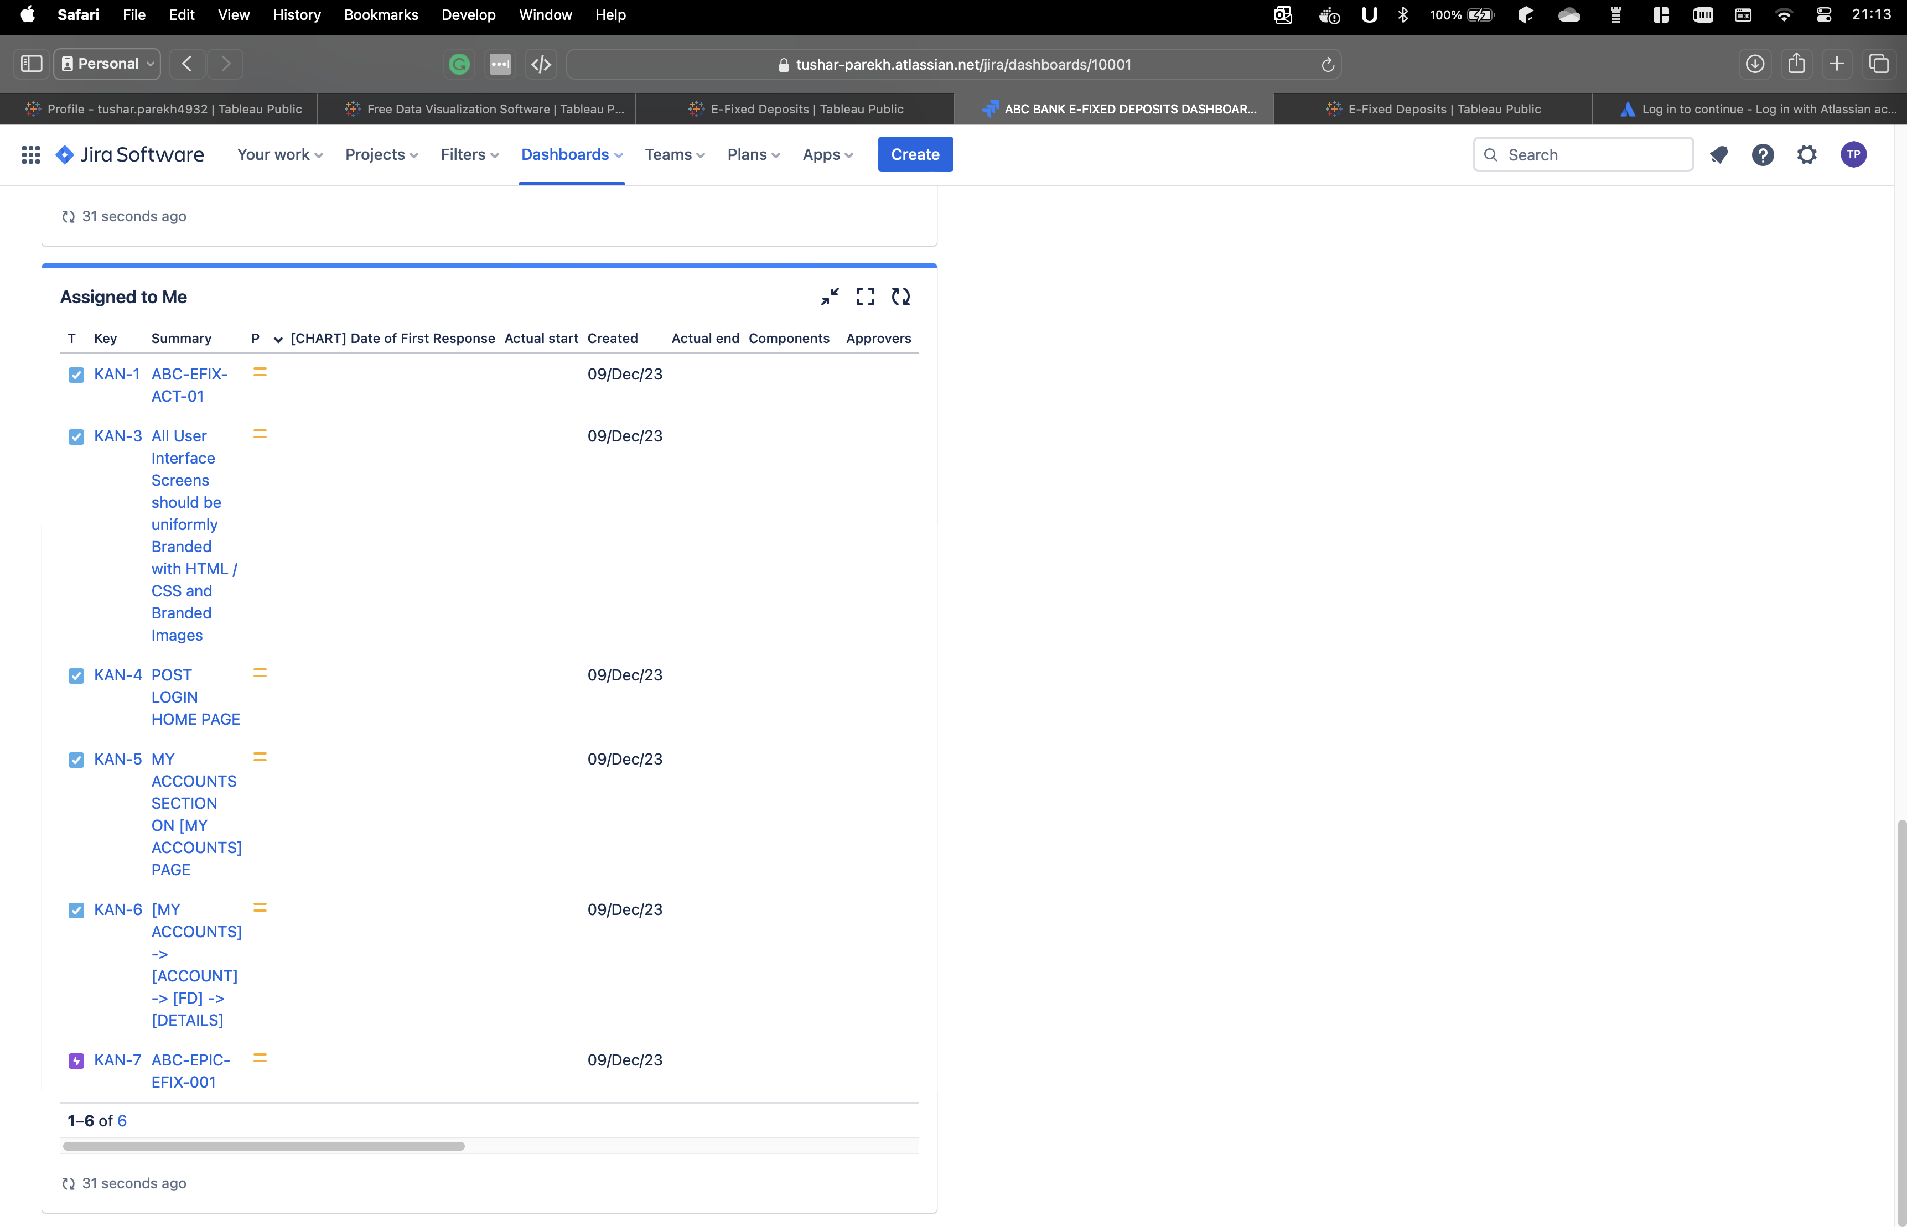

Link to the above Jira Project for review is as follows :

<https://tushar-parekh.atlassian.net/jira/dashboards/10001>



WEEK 3 : TABLEAU DASHBOARD

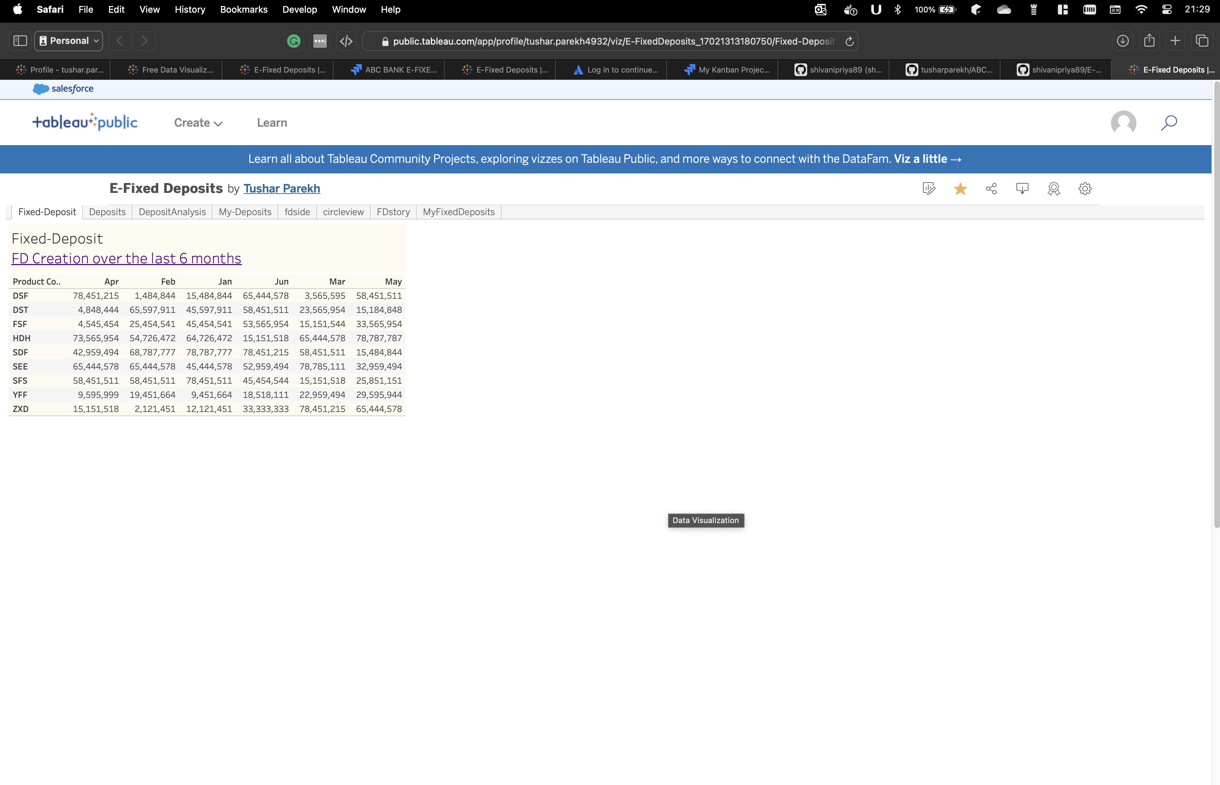

To access the above Dashboard please check out the below link for review :

<https://public.tableau.com/app/profile/tushar.parekh4932/viz/E-FixedDeposits_17021313180750/Fixed-Deposit?publish=yes>

WEEK 4 – EXCEL DEPOSIT ANALYSIS

**Excel Task on E-Fixed Deposit**

Q1) Create a bar graph showing the FD sales for different periods of investment. Draw two bar graphs: one for normal users and other for senior citizens. label the chart drawn correctly so that senior management gets a clear report of sales.

Ans) The bar graph of Fixed Deposit for normal users is mentioned below:

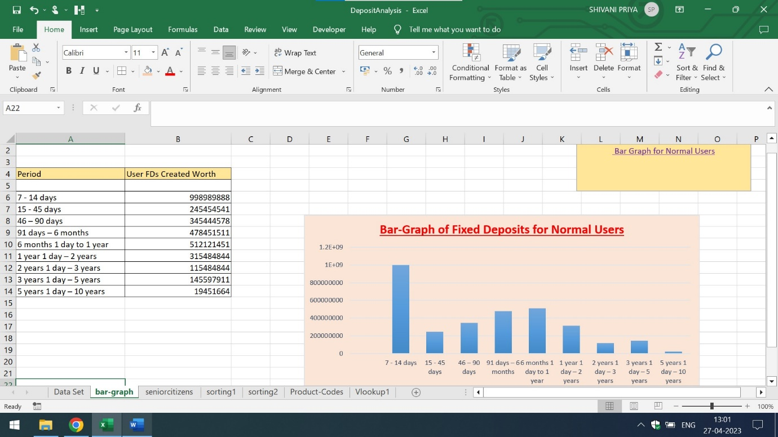

The bar graph of Fixed Deposit for senior citizens is mentioned below:

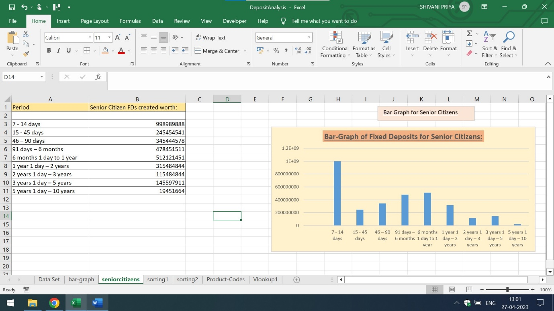

Q2) Arrange the data above in excel in ascending and in descending order

Ans) The representation of tabular data in ascending order is mentioned below:

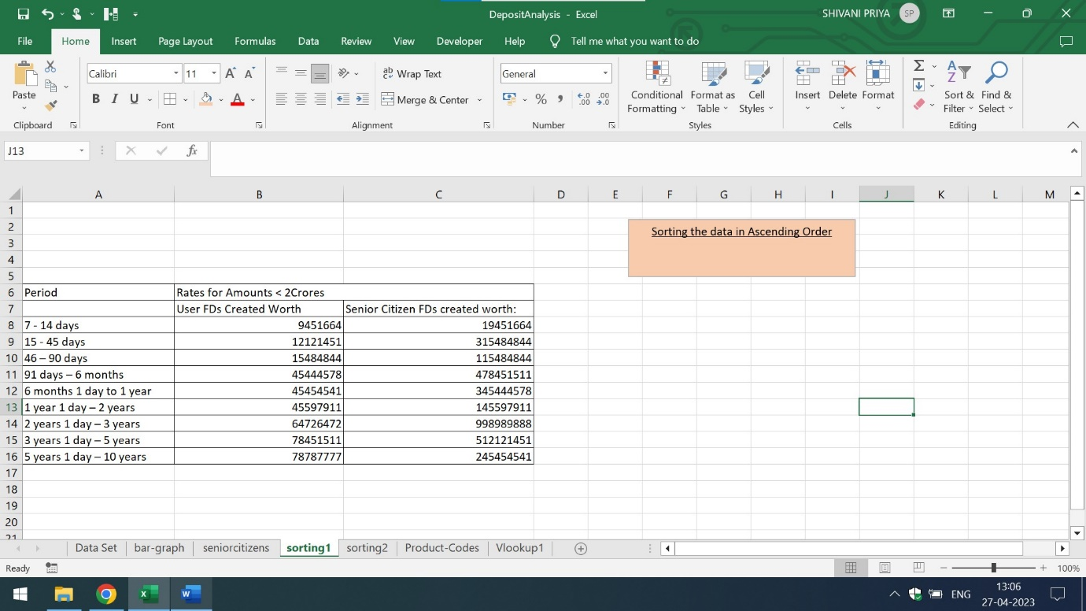

The representation of tabular data in descending order is mentioned below:

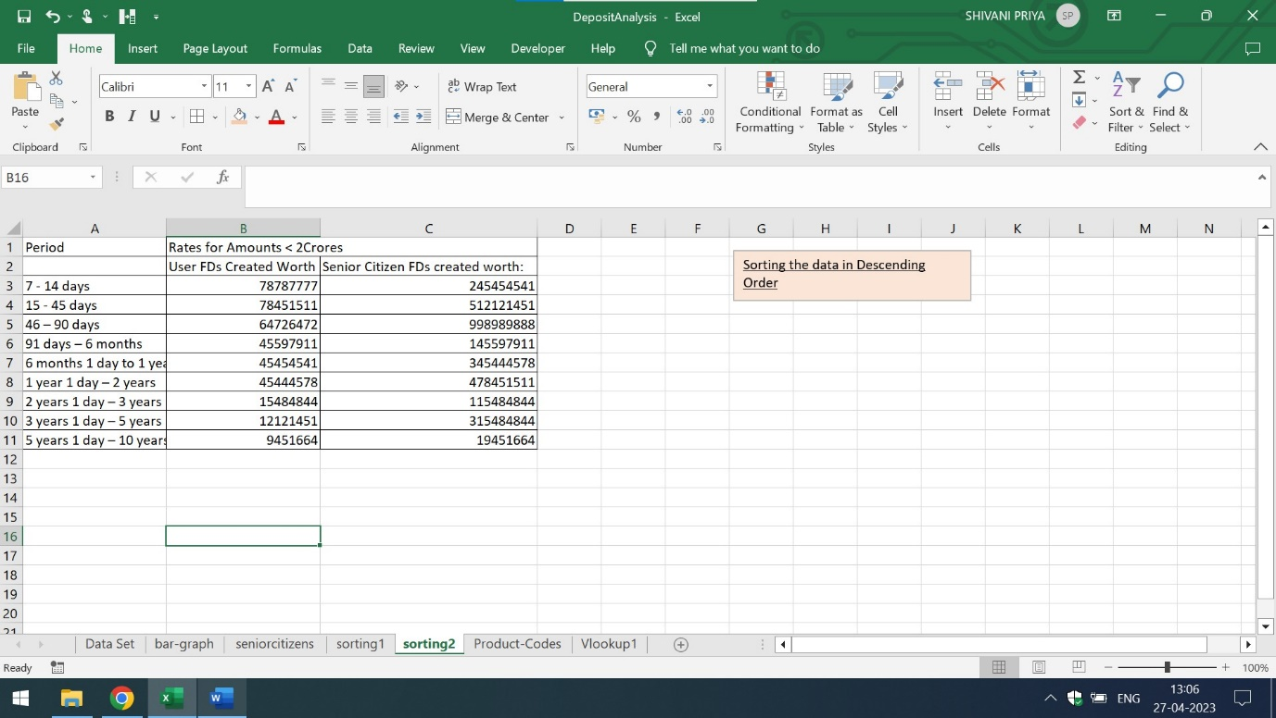

Q3) Using vlookup for product code HDH, find the rate for senior citizens for amounts less than 2 crore.

Using vlookup for product code YFF, find the rate for senior citizens for amounts less than 2 crore.

Ans) The rates for senior citizens for product code HDH and YFF for amounts less than 2 crore is mentioned below:

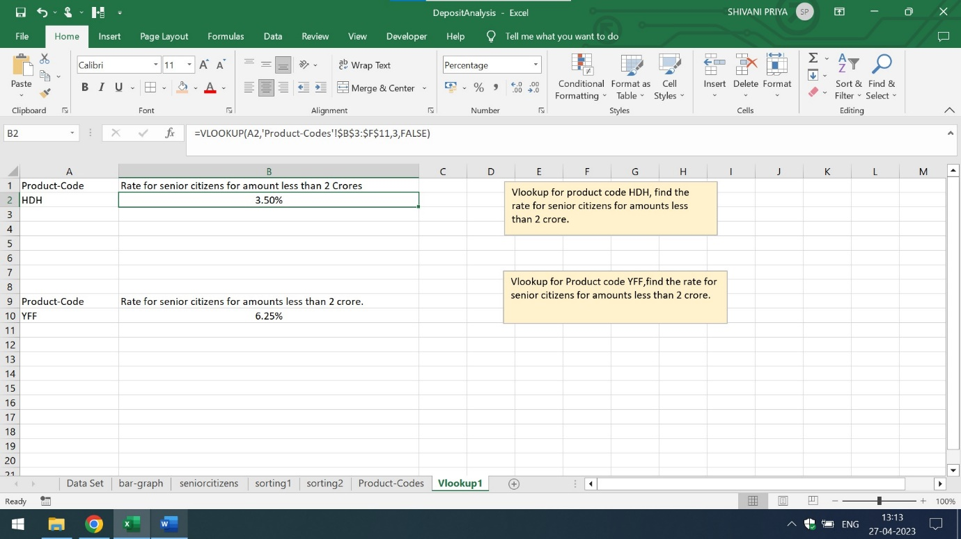

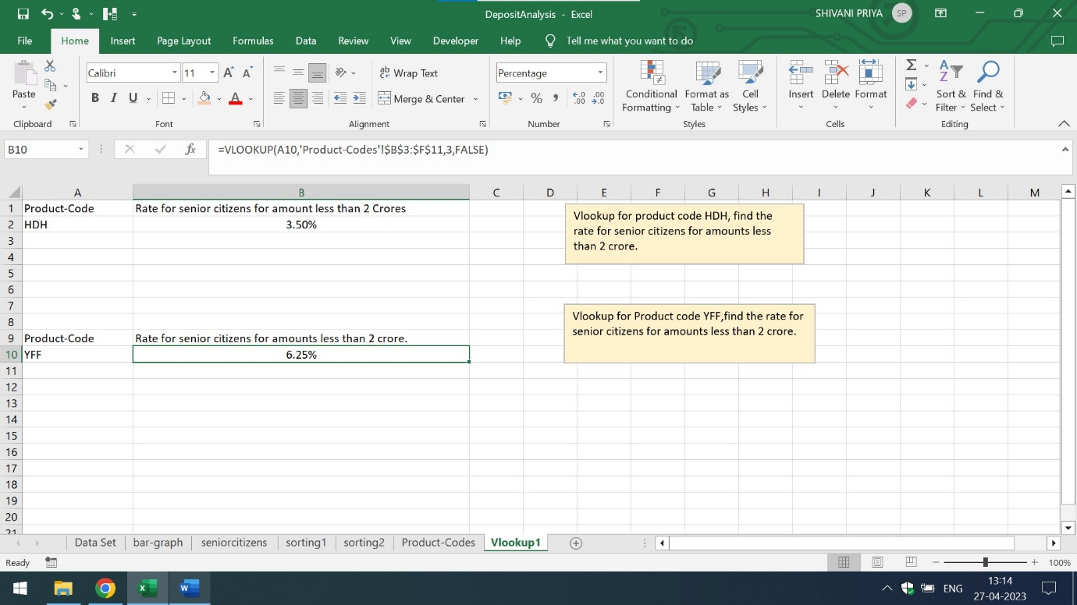

Kindly click on the below mentioned link

<https://github.com/tusharparekh/ABC-Fixed-Deposit-Business-Analysis.git>

and download the excel sheet for more detailed explanation